Opiniano, Ezkylle 01/27/2026
NW – 301 6BLOCKTECH
Midterm Lab Activity 5: Step by Step of Creation of ERC20 Token
Full Code
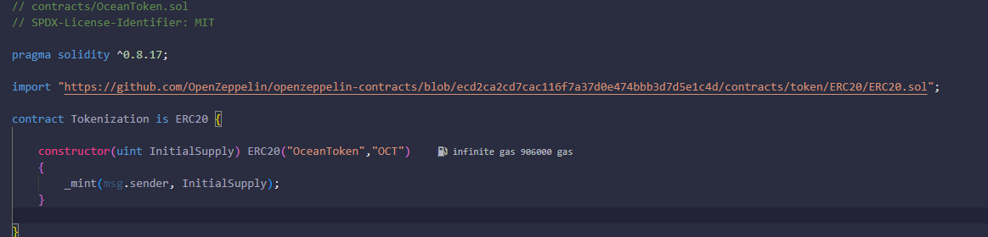Deploying and Checking balance, name, and symbol.
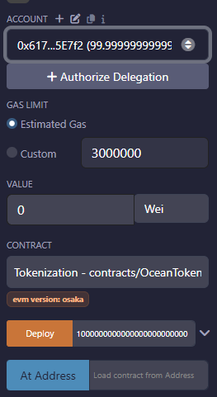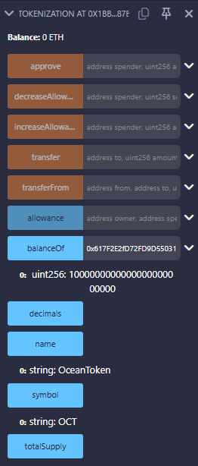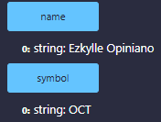
Transferring 10000000000000000 to a 2nd account
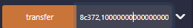
Checking if 10000000000000000 is successfully transferred to the 2nd account
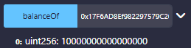
Checking if the first account has reduced balance
Before:
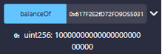
After:
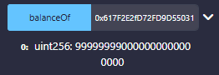

Reflection:
- Practical Use: If you were to launch your own token today, what specific problem would it solve or what "real world" item would it represent?
If I were to create an ERC20 token, it would represent fitness rewards. Users would earn tokens by completing healthy activities like workouts, running, or attending wellness classes. The tokens could be redeemed for gym memberships, fitness gear, or wellness services, and could even be traded or gifted to others. This system motivates people to stay active, makes rewards transparent and portable, and leverages blockchain to track and verify healthy habits securely.
- Security & Trust: Why is it safer to use a standard library like OpenZeppelin rather than writing your own token code from scratch?
Using OpenZeppelin is safer because it’s battle-tested, audited, and widely used, reducing bugs and exploits. Writing your own token from scratch risks critical security flaws that attackers actively look for.

